Find a transfer that allows you to approach it from any direction, such as a bed, mat table or couch. Set up your wheelchair to transfer, then answer the following questions.
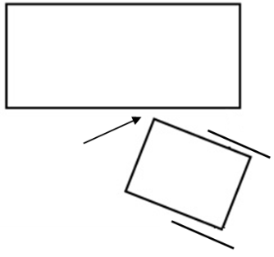
- How far is the front of your wheelchair from the object to which you are transferring? (you can use a ruler to measure)
  - Less than 3 inches
  - 3-5 inches
  - Greater than 5 inches

- What is the angle between your wheelchair and the mat?
  - 0-10 degrees
  - 20-45 degrees
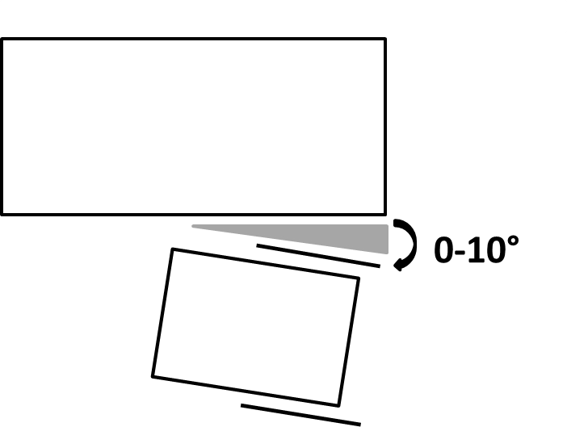
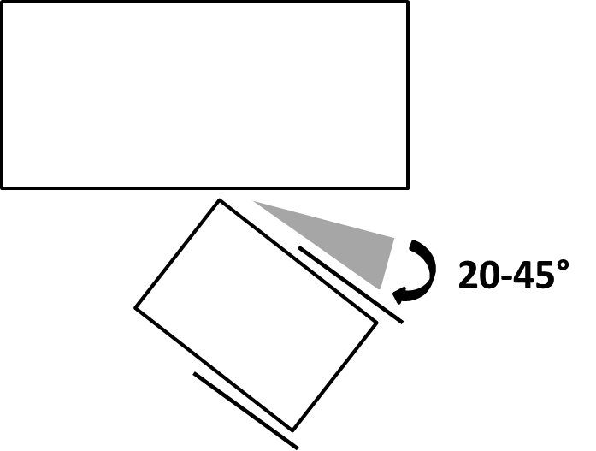
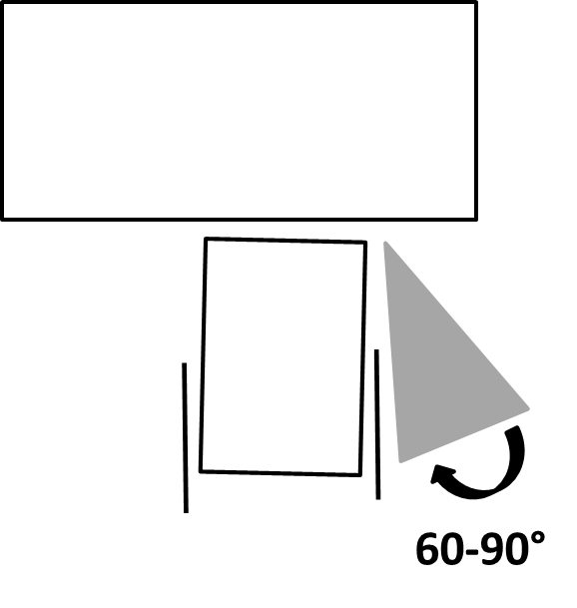
  - 60-90 degrees

- Did you lock the brakes on your wheelchair?
  - Yes
  - No
  - Not applicable, my wheelchair does not have brakes
- Did you remove the armrest from your chair?
  - Yes
  - No
  - Not applicable, my wheelchair does not have armrests
  - Not possible, my wheelchair has armrests but they cannot be removed
- Did you remove the clothing/sides guards from your chair?
  - Yes
  - No
  - Not applicable, my wheelchair does not have clothing/side guards
  - Not possible, my wheelchair has clothing/side guards but they cannot be removed
- Was your transfer set up to be level (top of cushion is level with the surface you are transferring to)?
  - Yes
  - No
  - Not possible

Position your arms and body for the transfer, then answer the following questions.
- What is the angle between the arm on the surface you are transferring to and your body?
  - 30-45 degrees
  - 60-75 degrees
  - Greater than or equal to 90 degrees
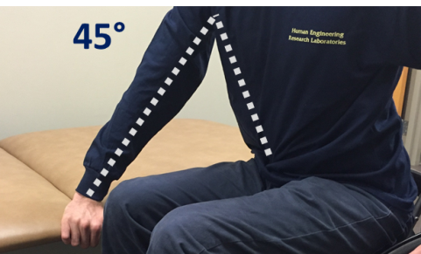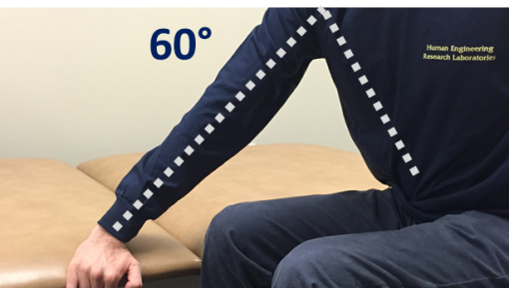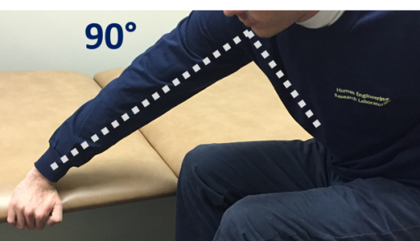
- Are your feet on the floor?
  - Yes
  - No
  - Not possible
- Did you scoot to the front 2/3 of your seat?
  - Yes
  - No
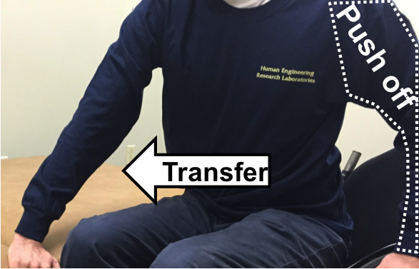
  - Not possible
- Where is your push off hand (see image) in relation to your body?
  - Close to my body
  - 6 or more inches from my body

- Check the box of the type of hand position that most closely represents the hand position you are using with your push off hand (see image)?

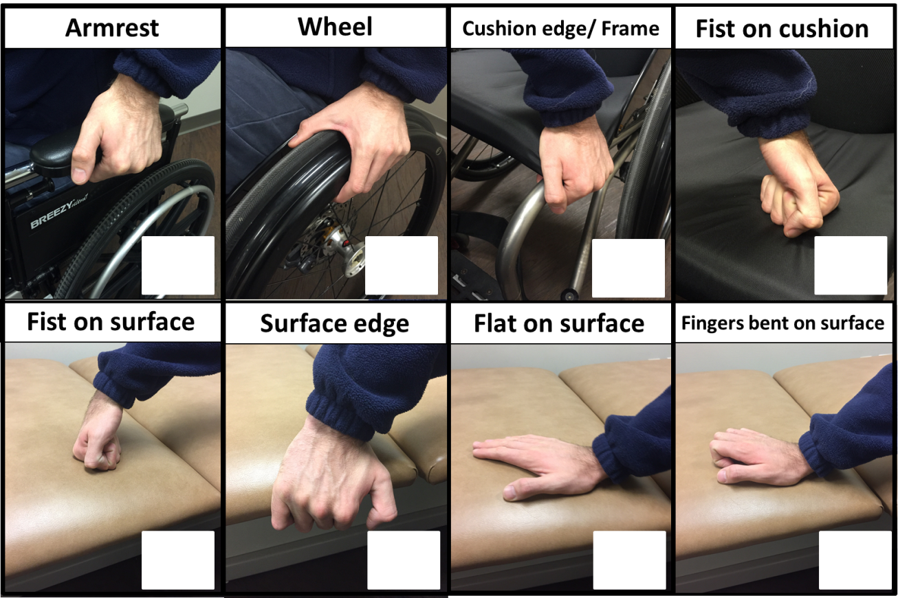

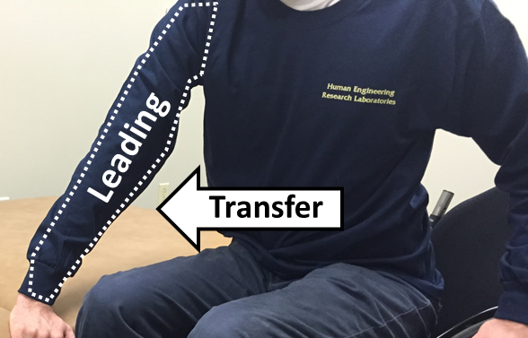
- Check the box of the type of hand position that most closely represents the hand position you are using with your leading hand (see image)?
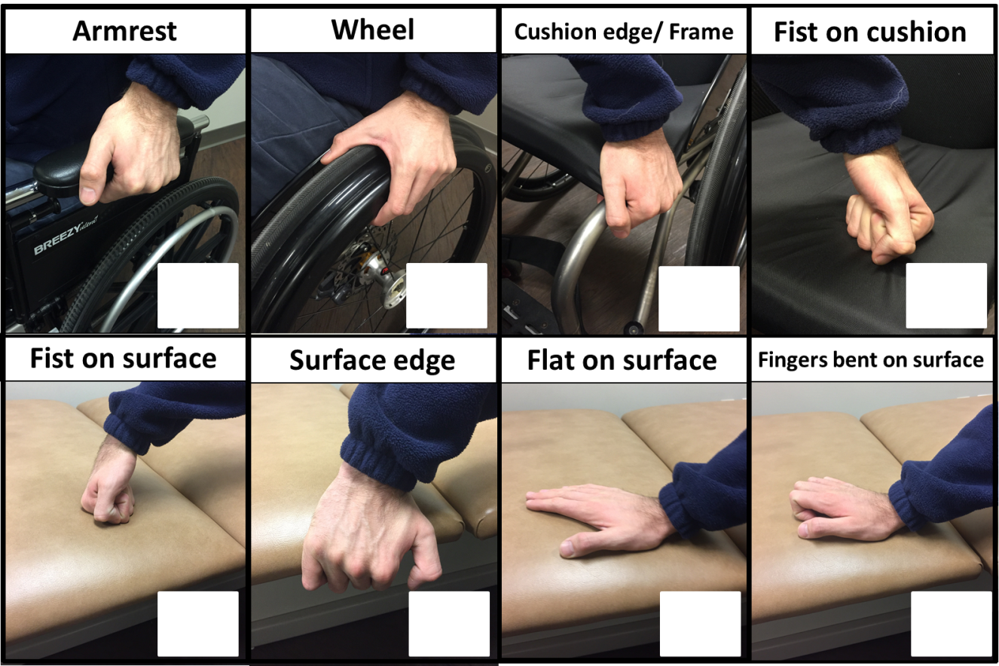

Complete your transfer between surfaces, then answer the following questions.
- Where was your leading hand (see image) placed?
  - Close to where my hips landed
  - 6 inches or more from where my hips landed

- When you moved between surfaces was it smooth and well controlled?
- Yes
- No
- How was your trunk positioned during the transfer?
- Bent at the waist; looking straight ahead I saw my toes
- Body was upright; looking straight ahead I saw across the room
- Leaning back; looking straight ahead I saw the ceiling

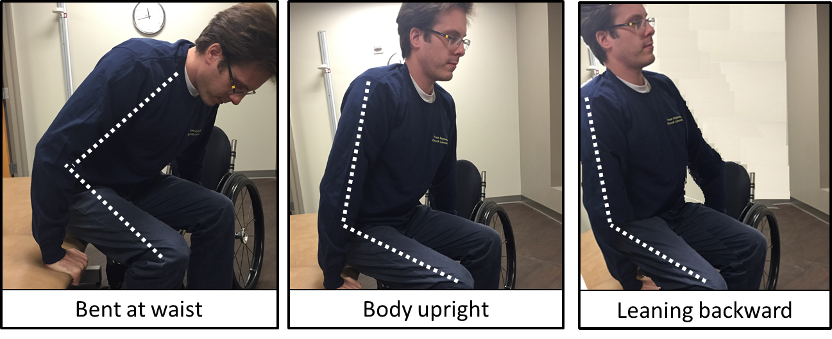
- How did your head move in relationship to your hips during the transfer?
- They moved together; my head and hips both moved towards the surface I was transferring
- They moved in opposite directions; my hips moved towards the surface I was transferring to while my head moved away
- I’m not sure
- Were both of your hands in contact with a surface (bed/chair/wheelchair) at the end of a transfer?
- Yes
- No, only one hand
- No, neither hand
- Did you land in a soft, smooth and controlled manner?
- Yes
- No

